

**UNIVERSITY OF GHANA, LEGON**

# *(All rights reserved)*

**DEPARTMENT OF COMPUTER ENGINEERING**

**SCHOOL OF ENGINEERING**

**SEMESTER 1 2022/2023 ACADEMIC YEAR**

**Database Group Project Documentation**

**Course Code /Title: CPEN 211 Database System Design**

**Credits: 3**

**CPEN 211 GROUP 2**

**MICHELLE OWUSU - 10957340 BENTIL B. REXFORD - 10946257**

**MENSAH NYANYO HUBERT - 10976127 EVANS ACHEAMPONG - 10987644**

**ANANE GEORGE NYARKO - 10947340 APPIAH YAW FRIMPONG - 10987818**

**DERY-KUUZUME SANDRA - 10986424**

**Insurance Management System Project**

**Introduction**

Insurance is a critical aspect of financial management, and insurance companies need to manage data and customer information effectively to provide quality services. The Insurance Management System project aims to develop an online application that automates work procedures for an insurance company. The proposed system is designed to manage data and records, including customer information, policy details, and transactions. This report provides a detailed description of the project, including the system's requirements, design, implementation, and testing.

**Abstract**

An organization must have accurate and reliable data for effective decision-making. To this end, the organization maintains records on the various facets of maintaining relationships among them. Such related data are called a database. A database system is an integrated collection of related files, along with details of the interpretation of the data contained therein. Basically, the database system is nothing more than a computer-based record-keeping system, i.e., a system whose overall purpose is to record and maintain information/data.

For our project, we would be designing a database system for an insurance company/agency which would aid in storing, managing, retrieving, and making changes in the records of the agency. This vacation, we chanced on a couple of insurance companies and agencies which needed software, and in effect a database, for their clients. Most of them required software that would have the records of all their clients, client details, details of insurance policies, and other necessary data the insurer needs. We realized that most of these agencies use notebooks and pens to manually enter their businesses thus making it difficult to keep records of every one of their clients and hence, the design of a database system would relegate manual record-keeping.

The main aim of this project is to develop an online application for the insurance company to atomize work procedures. Using this system, agents and policyholders can know details about present policies, policy specifications, terms and conditions on a stated policy, and policy registration by the customers. Agent’s commission is based upon customer policy registration and target agent achieves for every month or year. This system maintains information about branch managers who can deal with agents and customers.

In the existing system, a manual procedure where records are used to manage data is employed. This is a time-taking process and requires much manpower. Calculations and calculating commissions and dues are done manually.

In the present system, there is no need for human interference in calculating any details. Total work is done using a management system which will save time and less paperwork and even human resource.

This application is implemented in three modules**: manager, agent,** and **customer.**

**Manager Module:**  This module is managed by managers from different branches for recruiting agents, registration of customers, and agents’ commission calculation based on agents’ performance.

**Agents Module:**

This module is used to provide policy information for agents and commission information, agents’ personal details, and manager details.

**Customer Module**: Using this module customers can log in to accounts and know details about policy percentages and the total amount they paid and pending payment details.

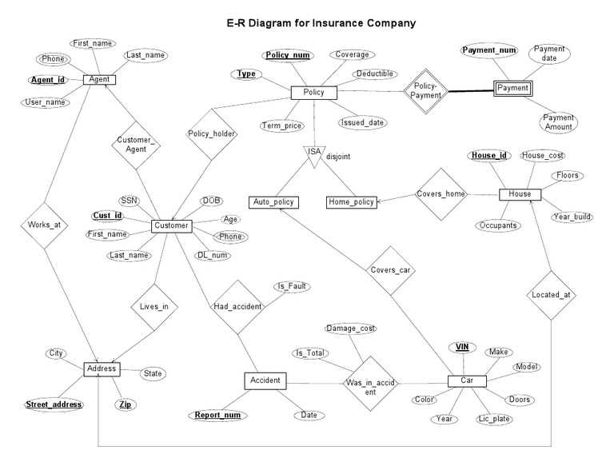

The image above is an Entity Relationship (ER) Diagram for the Insurance Company.

**Project Requirements**

The Insurance Management System project has several requirements that the system must meet. The project's primary objective is to automate manual calculations and provide easy retrieval of stored data. The system must provide secure and user-friendly access to the database for managers, agents, and customers. The system should also provide accurate calculations of commissions and dues based on agents' performance. Additionally, the system must provide descriptive reports to help management make informed decisions. Other requirements include the ability to manage customer details, policy information, and transactions accurately.

**Drawbacks of the existing system**

The existing system has no security measures against logging in and no checks are made for authorized users.

The end-user has to remember a lot of commands to make efficient use of the system.

The system does not have any descriptive report and thus does not help management in decision-making.

**Proposed system**

The proposed system is to computerize the agent and client department for various purposes.

The main objective is to automate manual calculations and easy retrieval of the stored data.

1. The database could include the following tables

1. Customer Info, with fields for ID, Last Name, First Name, Address, City, State, Zip, Phone, Credit Card Number, Exp Date, Multi Policy Discount, DOB.

2. Auto, with fields for Auto Policy Number, ID, Make, Model, Year, Liability Amount, UM, UIM, Med Pay, Premium Amount, Collision Damage Amount, Named Insured, Additional Driver.

3. Homeowners, with fields for Homeowners Policy Number, ID, Liability Amount, Property Damage Amount, Premium.

4. Renters, with fields for Renters Policy Number, ID, Liability Amount, Property Damage Amount, Premium.

5. Life Ins, with fields for Life Ins Policy Number, ID, Premium amount, Benefit Amount, Beneficiary.

The Customer Information table would contain basic customer contacts, some biographical information, and payment information.

The Auto table would contain information related to a customer’s automobile policy.

Also needed would be transaction tables for transaction-related data:

1. Payments, with fields for Payment Transaction ID, ID, Due Date, Amount Due, Amount Paid, and Paid on Time. 2. Claims, with fields for Claim Transaction ID, ID, Amount of Claim, and Claim Approved. The database schema should avoid data redundancy, maintain data integrity, and organize data in a logical manner.

**System Implementation**

The Insurance Management System project is implemented using web-based technologies. The system's front end is designed using HTML, CSS, and JavaScript, while the back end is designed using PHP and MySQL. The system's user interface is designed to be simple and user-friendly, enabling managers, agents, and customers to access the system easily.

**System Testing**

The Insurance Management System project undergoes various testing stages to ensure that it meets the project's requirements. The testing stages include unit testing, integration testing, and system testing. Unit testing involves testing individual components of the system, while integration testing involves testing the system's integration with other systems. System testing involves testing the system as a whole to ensure that it meets the project's requirements. The system's testing phase is critical to ensure that the system is reliable, efficient, and meets the project's objectives.

**Conclusion**

The Insurance Management System project aims to create an online application that automates the work procedures of an insurance company/agency. The proposed system would provide a secure, user-friendly, and efficient database system for the management, agents, and customers of the agency. It would eliminate the need for manual calculations, reduce paperwork, and provide quick access to stored data. By automating the system, the proposed system would increase productivity and reduce the chances of errors.